'Embedded Systems' EXPERIMENT 3
CONFIGURING GPIO PORTS OF TM4C123GH6PM FOR DIGITAL I/O
From
Name::M Husnain
Khalid
Roll No: 22l-6286
Instructor:Muhammad Ahmad

Exercise 1

#include <stdio.h>
#include <stdint.h>
#include "C:\ti\TivaWare_C_Series-2.1.4.178\inc\tm4c123gh6pm.h"
#define SW1 (GPIO_PORTF_DATA_R = *((volatile unsigned int *)0x40025040))
void PortF_Init(void){
SYSCTL_RCGCGPIO_R |= 0x00000020; // activate clock for Port F
while((SYSCTL_PRGPIO_R&0x00000020) == 0){};// ready?
GPIO_PORTF_LOCK_R = 0x4C4F434B; // unlock GPIO Port F
GPIO_PORTF_CR_R = 0x14; // allow changes to PF2 & PF4
GPIO_PORTF_DIR_R = 0x04; // PF4 in, PF2 out
GPIO_PORTF_PUR_R = 0x10; // enable pull-up on PF4
GPIO_PORTF_DEN_R = 0x14; // enable digital I/O on PF2 & PF4
}
void main(void)
{PortF_Init();
while(1){
if (!SW1)
GPIO_PORTF_DATA_R=GPIO_PORTF_DATA_R^0x04;
}
}
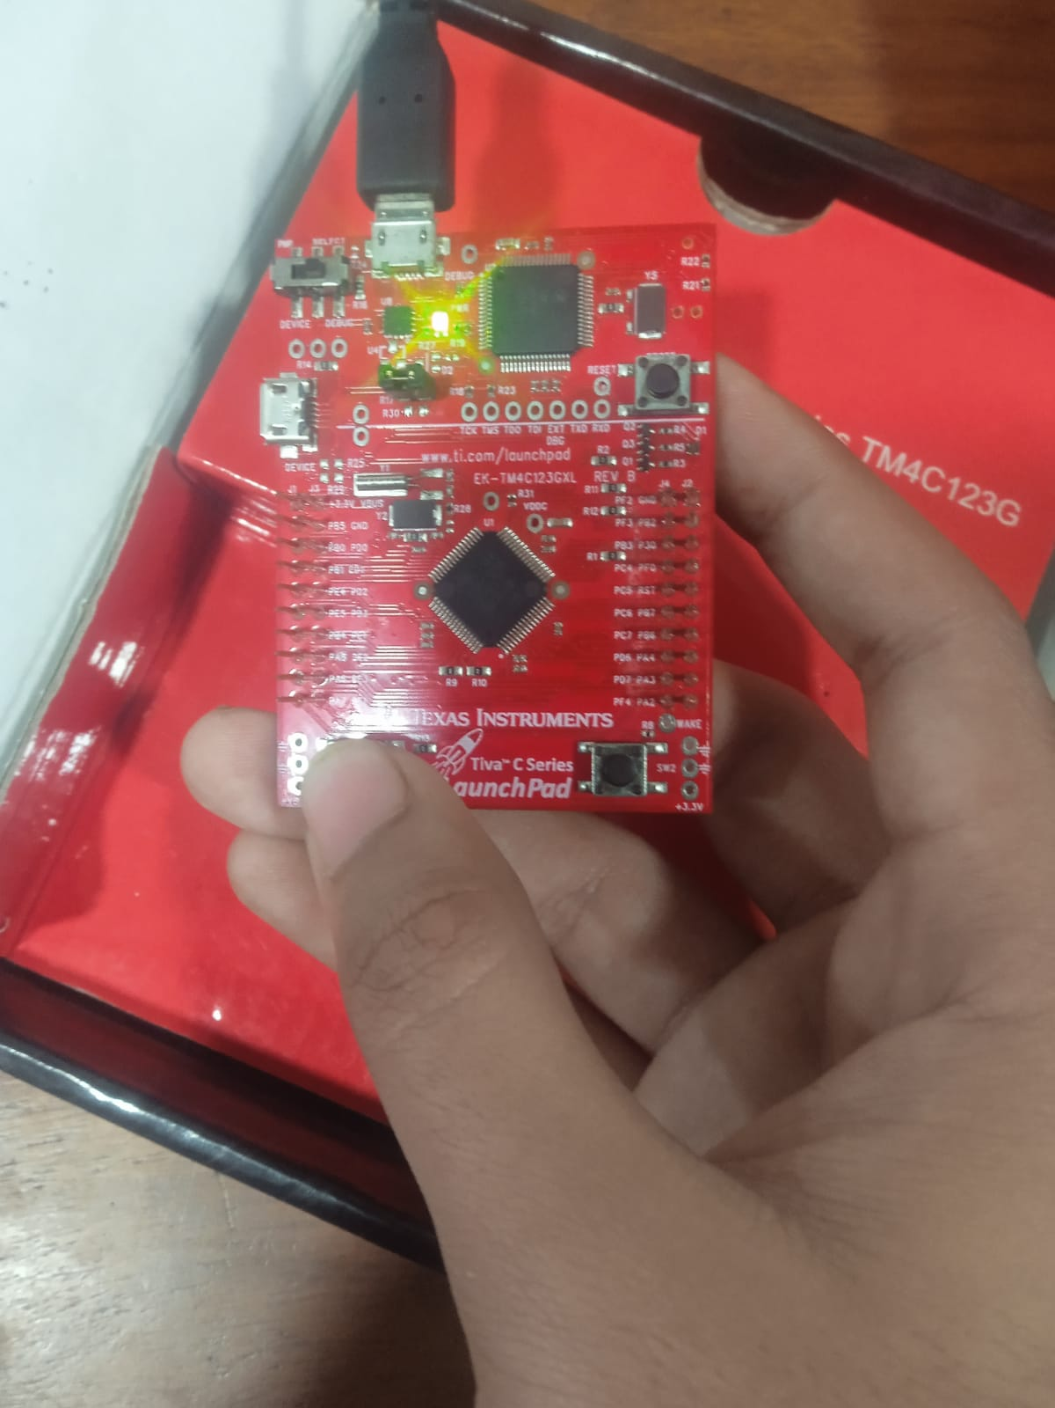
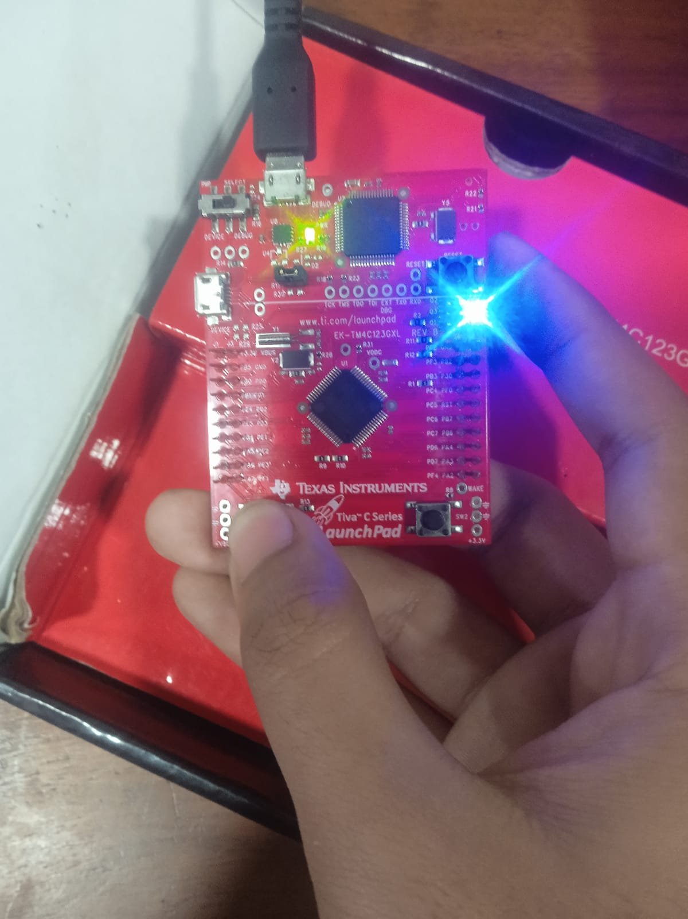

Exercise 2

#include <stdio.h>
#include <stdint.h>
#include "C:\ti\TivaWare_C_Series-2.1.4.178\inc\tm4c123gh6pm.h"

/*
PF1 - red LED
PF2 - blue LED
PF3 - green LED
*/

void delay()
{
uint32_t counter =0;
for (counter =0;counter<1500000;counter++);
}

int main(void)
{
volatile uint32_t j;

SYSCTL_RCGCGPIO_R |= 0x00000020; // activate clock for Port F
GPIO_PORTF_LOCK_R = 0x4C4F434B; // unlock GPIO Port F
GPIO_PORTF_CR_R = 0x0E; // allow changes to PF2 & PF4
GPIO_PORTF_DIR_R = 0x0E;
GPIO_PORTF_DEN_R = 0x0E;

while(1){
for(j=0;j<8;j++)
{
GPIO_PORTF_DATA_R = (j<<1);
delay();
}
}
}
